
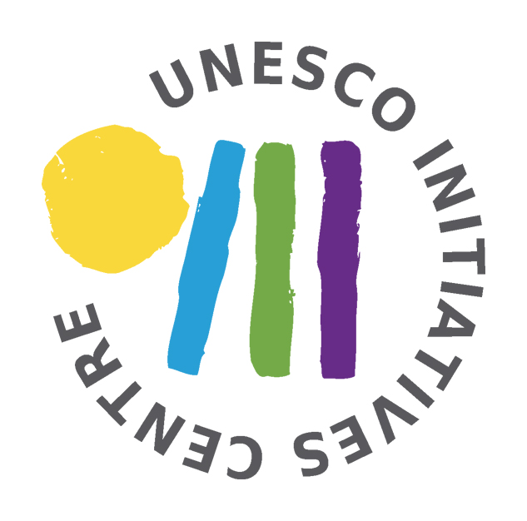



meet your borders
training course on using living library in cross border areas

July 17TH – 25th 2012
HRADEK NAD NISOU, Czech Republic

APPLICATION FORM

Contact Details
First Name: |  |  |  | Family Name:
Nationality: |  |  |  | Date of birth: |  |  | Gender:
Address:
Town/city: |  |  |  | E-mail: |  |  | Post Code:
Phone number: |  |  |  | Organisation: |  | ELIX – CONSERVATION VOLUNTEERS GREECE
Your role in organization:
Organizations’
website:
Your language skills (please state your level of English & list other languages you speak)
English: basic ◻ good ◻ advanced ◻

Other languages:

Other: Is there any information we should be aware of. (Special needs, diets, medication etc.)
What is your motivation to take part in this event? What are your expectations?
What are your experiences in organising / being involved in youth projects? In particular: did you ever hear / took part / help to organise a living library event?
Please describe as well your experience within Youth in Action Programme if you have any.
How would you multiply this training experince? What do you think you can do with it?
Where from did you learn about this training?
I confirm that I am committed to take part in the full duration of the event! I am aware that I have to take care of my travel tickets on my own (after final confirmation from ELIX), (reimbursement up to 70% after the training course).
I have read the project description and I'm aware that I have to contribute to my participation a participation fee (100€).
Date |  |  | Signature/name:
Thank you for taking your time and filling in this application form.
Please return this form before 19/06/2012 to email volunteers@elix.org.gr

